Two classes:

Class 1:

1. to find the elements using locators using POM 1 or POM 2
2. Constructor initiation to initiate the driver
3. Write methods to perform what action needs to be done on those elements like click / send keys / select etc.

Class 2:

1. Set system property
2. Initiate the web driver
3. Instantiating the class of POM1 or POM 2 like class1name name = new class1name(driver);
4. Using the variable call all methods to perform the desired operations like
5. Name.clickregister();

Before this you need to instantiate the web driver.

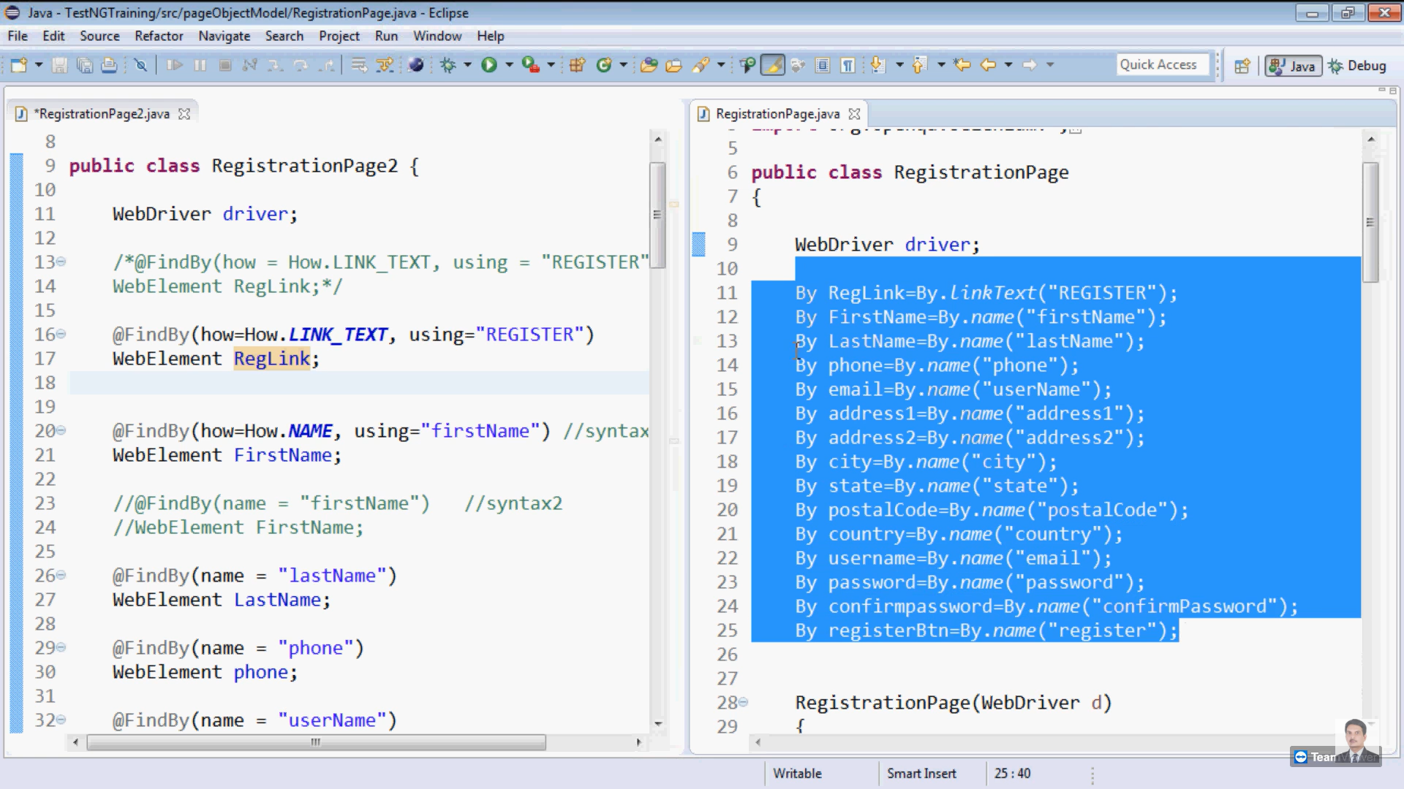

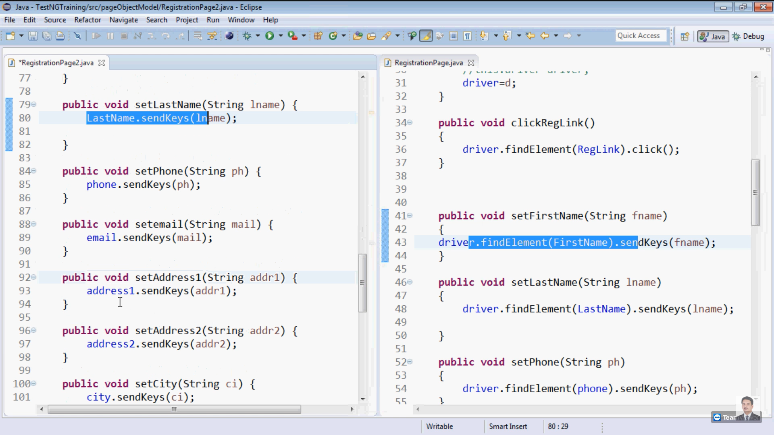

POM 1:

By Register = By.id(“Register”)

Public void clickRegister(){

Driver.findElement(Register).click();

}

POM 2:

@findElement(how = HOW.LinkText, using=”register”)

WebElement register;

(OR)

@findElement(LinkText =”register”)

WebElement register;

Public void clickRegister(){

Register.click();

}

**Driver initiation**

**POM 1:**

Using constructor (assuming class name 1 is registration) then

Registration(Webdriver d){

Driver=d;

}

**POM 2:**

Using constructor (assuming class name 1 is registration) then

Registration(Webdriver d){

Driver=d;

PageFactory.initElements(d,this);

}

In class 2:

@test

Public void registrationTest(){

System.setProperty(“webdriver.chrome.driver”,”C://user//[path of the driver]//chromedriver.exe”);

WebDriver driver = new ChomrDriver();

RegistrationClass1 reg = new RegistrationClass1(driver);

Reg.registrationlink();

.

.

Call all methods to perform the required actions